EXPERIMENT NO. 5
Student Attendance System using Zoho Creator (SaaS)

Aim
To develop a cloud-based Student Attendance System using Zoho Creator for maintaining attendance records.

Objective
• Store student attendance.
• Calculate attendance percentage.
• Generate reports.
• Demonstrate SaaS.

Software Requirements
Zoho Creator, Google Chrome, Internet Connection.

Theory
The application stores student attendance information in the cloud including course, attendance, OD request, grade and attendance percentage. Reports provide an overview of attendance.

Fields Used
Student Name, Register Number, Course, Present Classes, Absent Classes, Total Classes, OD Request, Grade, Attendance Percentage.

Algorithm
Start → Enter Student Details → Calculate Attendance → Submit → Store Record → Generate Report → Stop.

Procedure
1. Create application.
2. Design form.
3. Add fields.
4. Enter records.
5. Submit.
6. Create report.
7. View individual record.

Observation
Attendance records were stored successfully. Reports displayed all students. Individual records showed complete attendance details.

Result
The Student Attendance System was successfully implemented using Zoho Creator.

Conclusion
The experiment demonstrated SaaS-based attendance management.

Output Screenshots
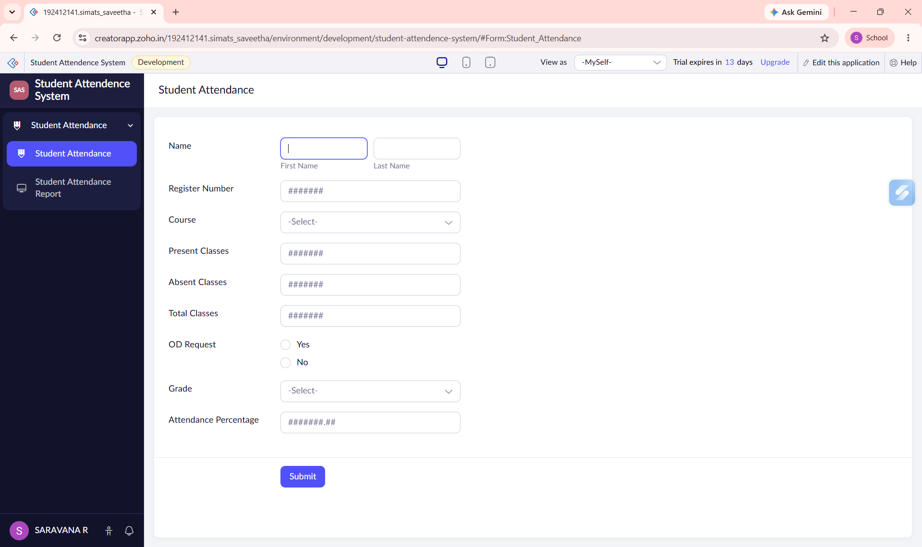
Figure 1: Attendance Form
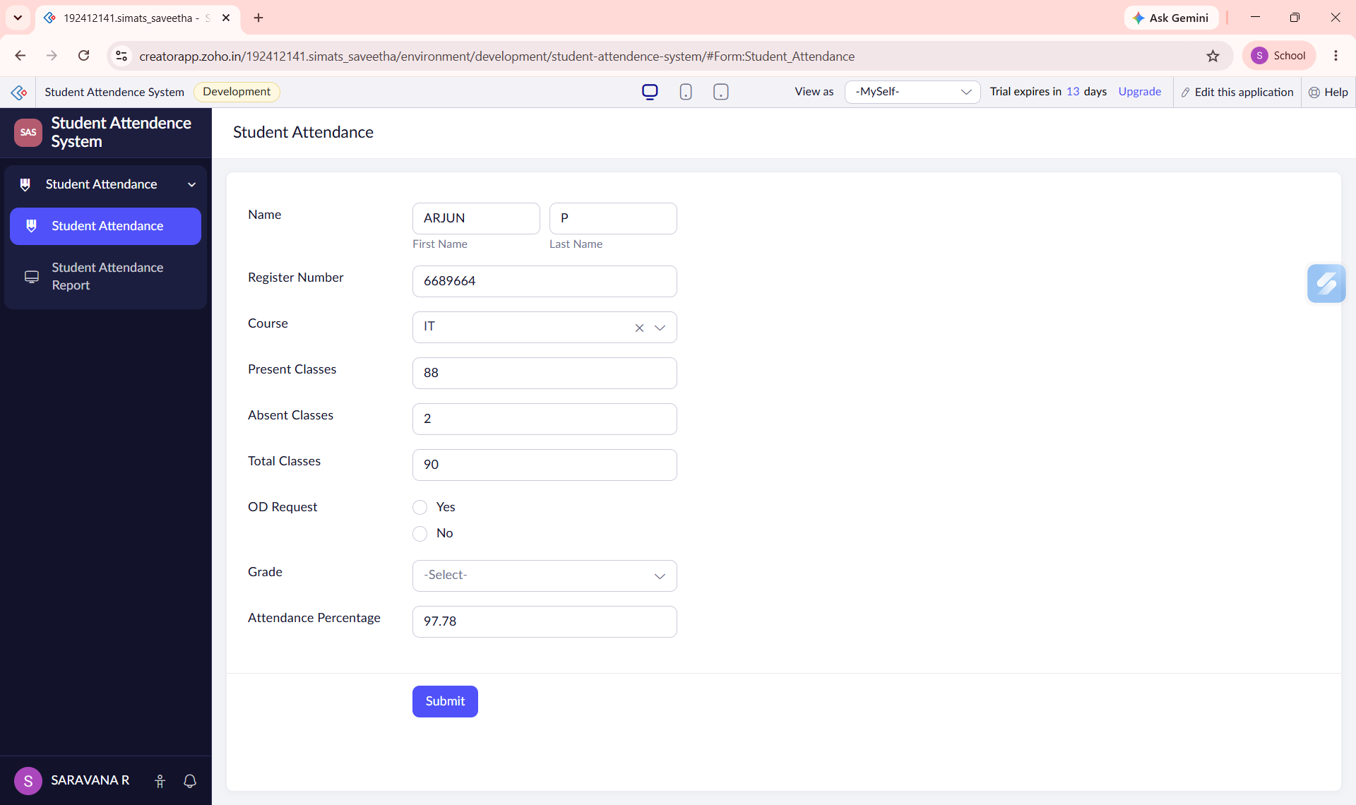
Figure 2: Total classes and Attendence Percentage calculated automatically
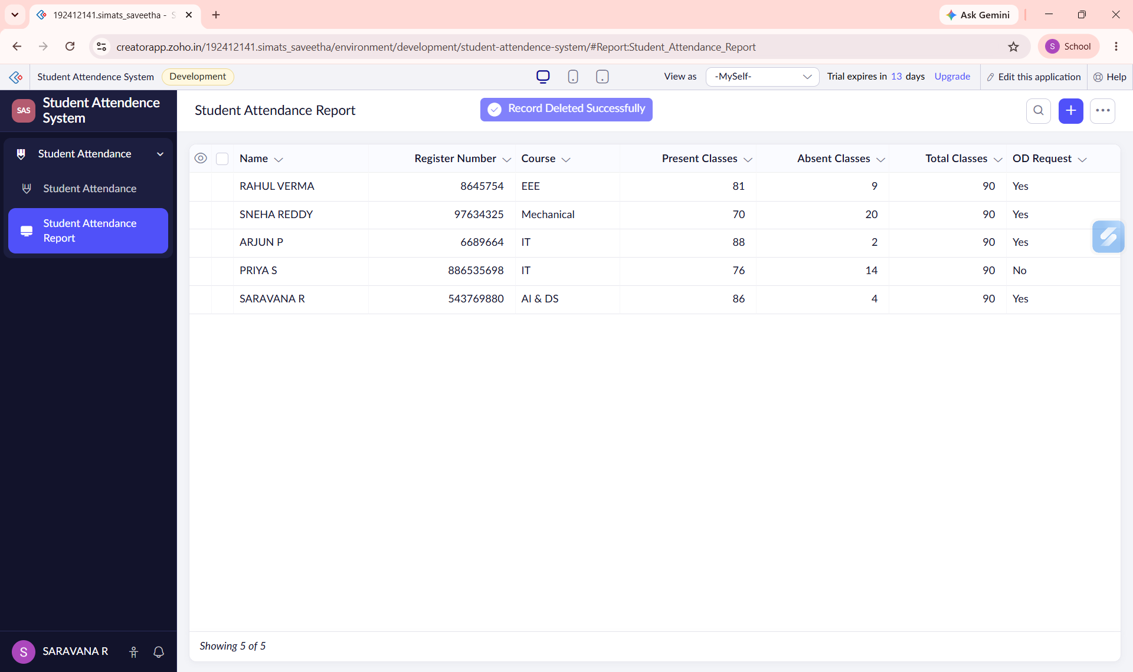
Figure 3: Attendance Report
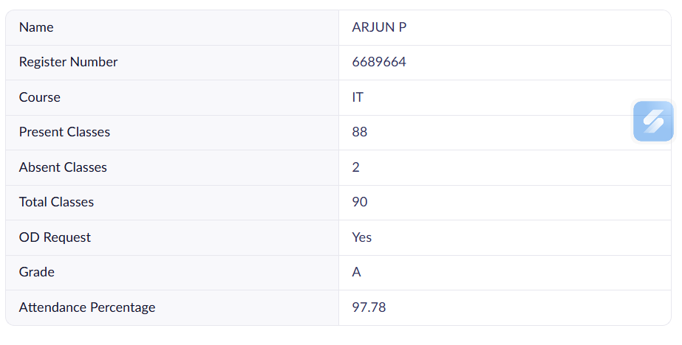
Figure 4: Individual Record

